**Design Document**



**Name**: Dawid Pionk

**Supervisor:** Jamal Tauseef

**Institution**: SETU, Carlow

**Date**: 21/02/2024

Table of Contents

Introduction 3

Flow Chart 4

Sequence Diagrams 5

Analyse Topic 5

View Detailed Sentiment 6

View Posts 7

View Guide 8

Prototype GUI 8

Home Screen 9

View Sentiment Screen 9

View Sentiment – More information Screen 10

View Sentiment – View Posts Screen 11

Guide Screen 12

# Introduction

In this document I am going to demonstrate the overall design of my web system. I am going to show how my user navigates the website using a flowchart. I am going to show how the system interacts with Reddit as well as the user using sequence diagrams. Screenshots of prototype web pages are included to show how I wish to implement the layout of the website.

# Flow Chart

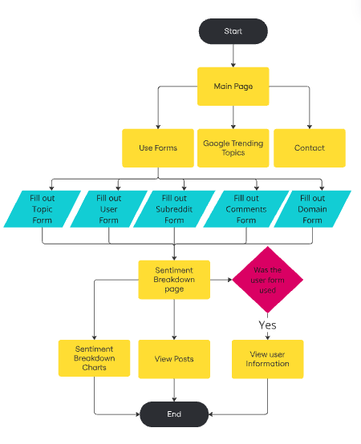

The flow chart above shows the order of actions the user can take. The user begins at the Main page, here the user can choose whether to view contacts or google trending topics. The user can make a request to analyze a sentiment of a specific subject using the forms present on the page. The user can choose to fill out one of these forms: topic form, user form, subreddit form, comments form or domain form. After the user submits the form, a query is made to Reddit's API using the provided parameters and the resulting posts are analyzed. From there the user can display information using charts or view specific posts. If the user made a query about a specific user that redditors account information can be viewed.

# Sequence Diagrams

## Analyse Topic

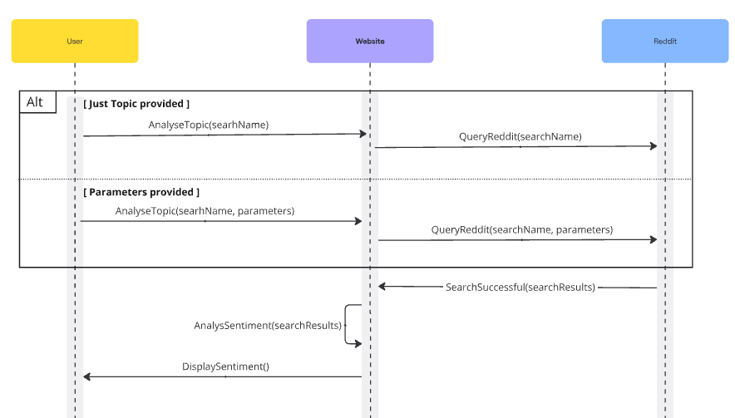In the sequence diagram above the user has 2 options either enter the topic by itself in the search of add additional parameters such as date or region specific. The website takes the input from the user and makes a query to Reddit's API within the given parameters. The tweets are then taken and processed by the website. Charts are created and the sentiment displayed for the user.

View Detailed Sentiment

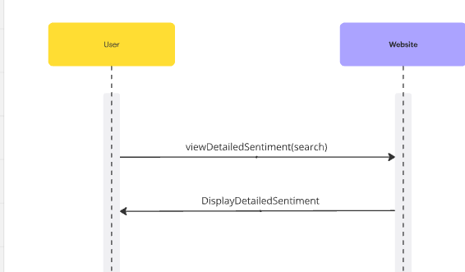

In the sequence diagram above the user requests the website for a more detailed view of the sentiment search. The website processes that request and creates charts and then displays them for the user.

View Posts

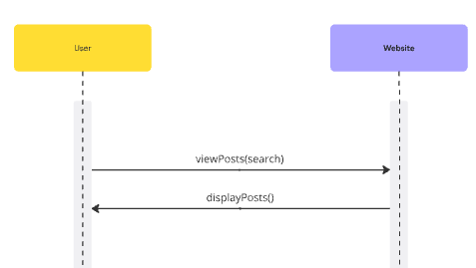

In the sequence diagram above the user requests the website for a detailed view of the posts and their sentiment. The website processes that request and displays the posts for the user.

View Guide

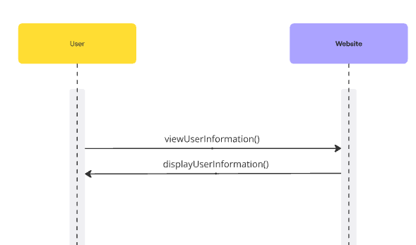

In the sequence diagram above the user requests the website for it to open the user information page. The website then displays the redditor information page for the user.

# Prototype GUI

## Home Screen

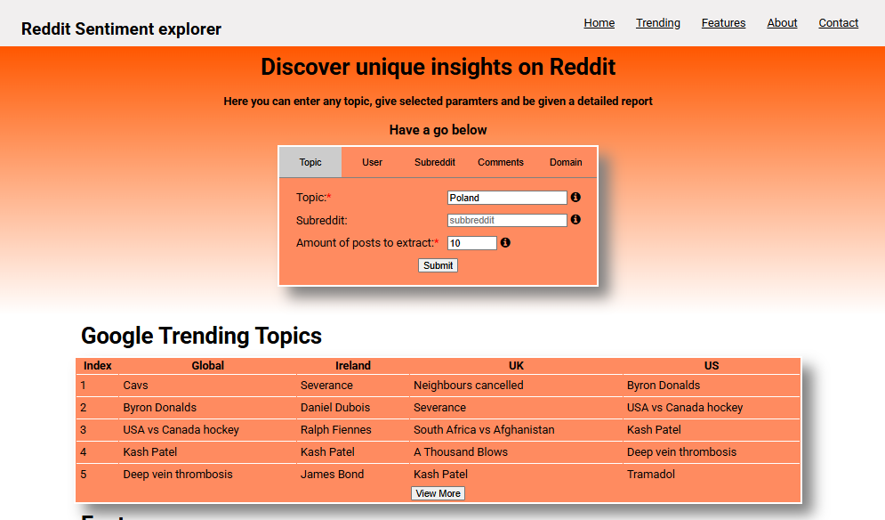Home Page

## View Sentiment Screen

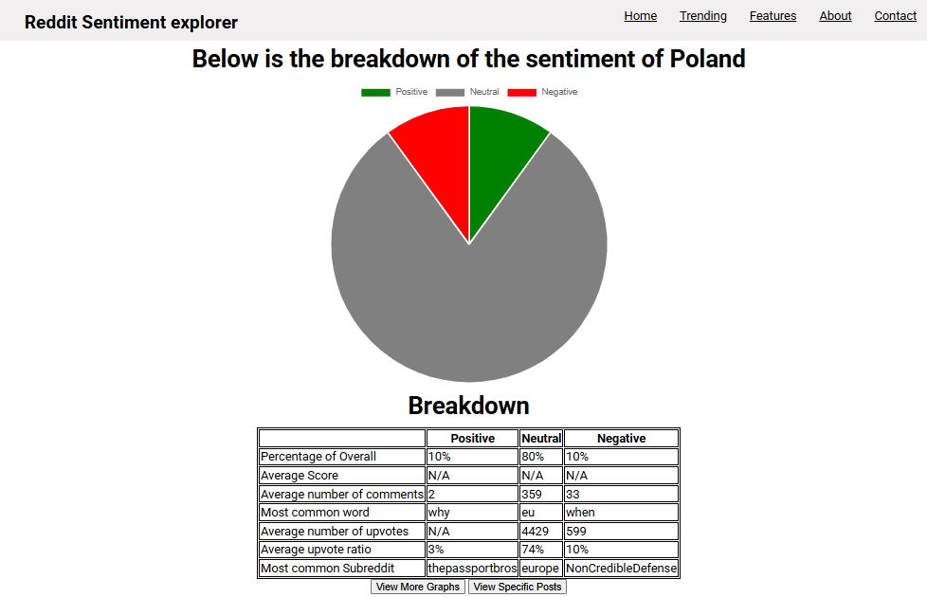Home Page => Sentiment Searched

## View Sentiment – More Charts Screen

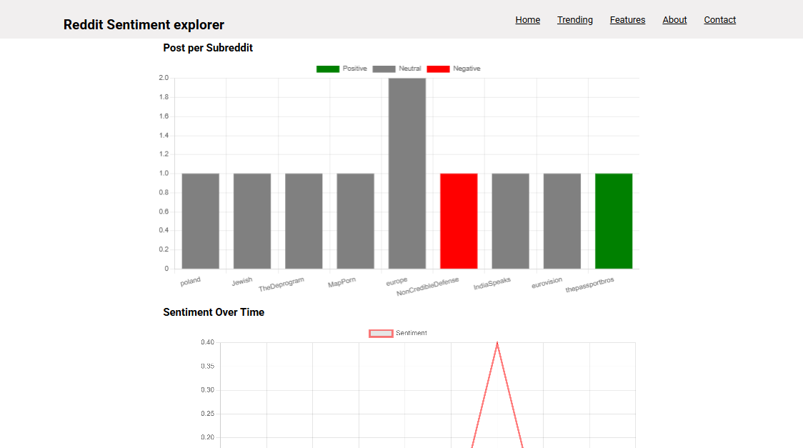

Home Page => Sentiment Searched => View Charts

## View Sentiment – View Posts Screen

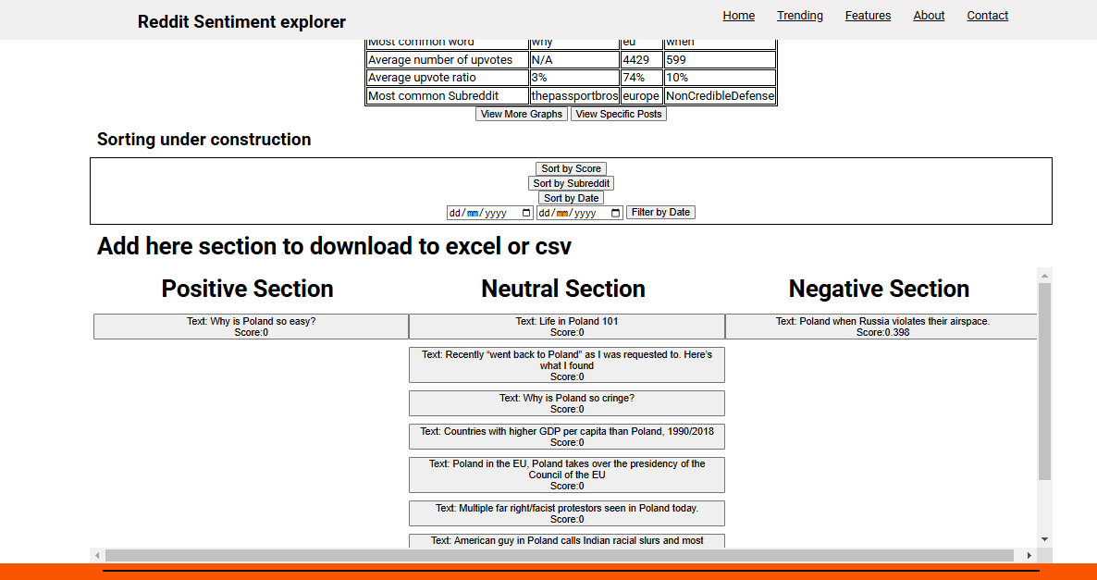Home Page => Sentiment Searched => View All Posts

## View User Information Screen

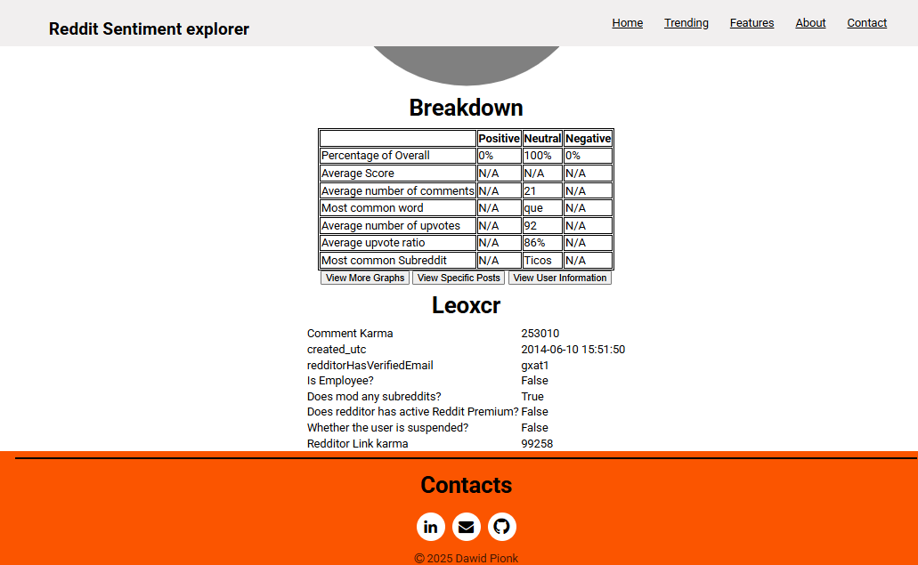Home Page => Sentiment Searched => View User Information